**Definition of nosql**

**\*\*\*\*\*\*\*\*\*\*\*\*\*\*\***

**NoSQL is not a relational database.**

**The reality is that a relational database model may not be the best solution for all situations.it is called not only SQL or non sql or non-relational.Early NoSQL databases used for web and cloud applications. NoSQL databases are document based, key-value pairs, graph databases or wide-column stores.**

**List of nosql databases:**

**\*\*\*\*\*\*\*\*\*\*\*\*\*\*\*\*\*\*\***

**NoSQL database examples: Mongo DB, Big Table, Redis, Raven DB, Cassandra, Hbase, and Couch DB**

**Characteristics of NOSQL Systems (or) advantages of NoSql**

* **It’s more than rows in tables—NoSQL systems store and retrieve data from many formats: key-value stores, graph databases, column-family (Big table) stores and document stores**
* **It’s free of joins—NoSQL systems allow you to extract your data using simple interfaces without joins.**
* **It’s schema-free—NoSQL systems allow you to drag-and-drop your data into a folder and then query it without creating an entity-relational model.**
* **It works on many processors—NoSQL systems allow you to store your database on multiple processors and maintain high-speed performance.**
* **It uses shared-nothing commodity computers—most (but not all) NoSQL systems leverage low-cost commodity processors that have separate RAM and disk.**
* **It supports linear scalability—When you add more processors, you get a consistent increase in performance.**
* **It’s innovative—NoSQL offers options to a single way of storing, retrieving, and manipulating data. NoSQL supporters (also known as NoSQLers) have an inclusive**
* **Attitude about NoSQL and recognize SQL solutions as viable options. To the NoSQL community, NoSQL means “Not only SQL.”**
* **High availability –  
  Auto replication feature in NoSQL databases makes it highly available because in case of any failure data replicates itself to the previous consistent state.**
* **High scalability – NoSQL database use sharding for horizontal scaling. Vertical scaling means adding more resources to the existing machine**
* **They can process both unstructured and semi-structured data.**

**Categories of NOSQL Systems (OR) TYPES OF NOSQL Databases**

NoSQL Databases**are mainly categorized into four types:**

* **Key-value Pair Based**
* **Column-oriented Graph**
* **Graphs based**
* **Document-oriented**

**Key Value Pair Based: Data is stored in key/value pairs. It is designed in such a way to handle lots of data and heavy load. Key-value pair storage databases store data as a hash table where each key is unique, and the value can be a JSON, BLOB (Binary Large Objects), string, etc. For example, a key-value pair may contain a key like “Website” associated with a value like “Guru99”.**

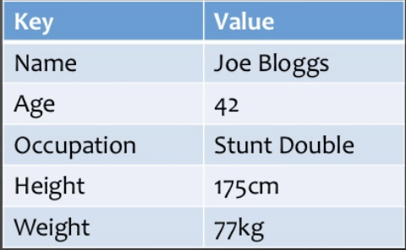

**It is one of the most basic NoSQL database example. This kind of NoSQL database is used as a collection, dictionaries, associative arrays, etc. Key value stores help the developer to store schema-less data. They work best for shopping cart contents.**

**Redis, Dynamo are some NoSQL examples of key-value store Databases. They are all based on Amazon’s Dynamo paper.**

### Column-based

**Column-oriented databases work on columns and are based on Big Table paper by Google. Every column is treated separately. Values of single column databases are stored contiguously.**

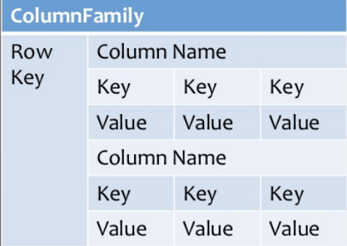

**They deliver high performance on aggregation queries like SUM, COUNT, AVG, MIN etc. as the data is readily available in a column.**

**Column-based NoSQL databases are widely used to manage data warehouses,**[**business intelligence**](https://www.guru99.com/business-intelligence-definition-example.html)**, CRM, Library card catalogs,**

**HBase, Cassandra, HBase, Hypertable are NoSQL query examples of column based database.**

### Document-Oriented:

**Document-Oriented NoSQL DB stores and retrieves data as a key value pair but the value part is stored as a document. The document is stored in JSON or XML formats. The value is understood by the DB and can be queried.**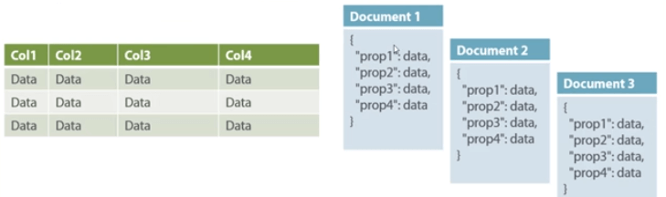

**Relational Vs. Document**

**In this diagram on your left you can see we have rows and columns, and in the right, we have a document database which has a similar structure to JSON. Now for the relational database, you have to know what columns you have and so on. However, for a document database, you have data store like JSON object. You do not require to define which make it flexible.**

**The document type is mostly used for CMS systems, blogging platforms, real-time analytics & e-commerce applications. It should not use for complex transactions which require multiple operations or queries against varying aggregate structures.**

**Amazon SimpleDB, CouchDB, MongoDB, Riak, Lotus Notes, MongoDB, are popular Document originated DBMS systems.**

### Graph-Based

**A graph type database stores entities as well the relations amongst those entities. The entity is stored as a node with the relationship as edges. An edge gives a relationship between nodes. Every node and edge has a unique identifier.**

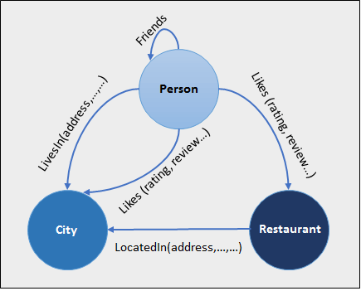

**Compared to a relational database where tables are loosely connected, a Graph database is a multi-relational in nature. Traversing relationship is fast as they are already captured into the DB, and there is no need to calculate them.**

**Graph base database mostly used for social networks, logistics, spatial data.**

**Neo4J, Infinite Graph, OrientDB, FlockDB are some popular graph-based databases.**